To setup a 32 bit ODBC connection on a 64 bit Windows server, first browse to this directory:

‘C:\Windows\SysWOW64’

Then order by ‘Type’ and find the ‘odbcad32’ application.

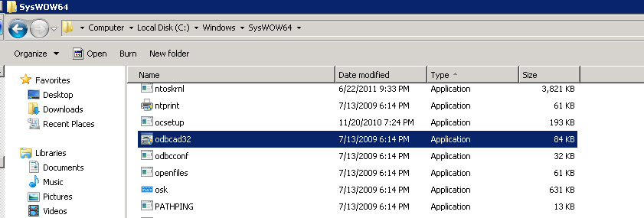

When you launch the application you will be taken into the 32 bit ODBC setup wizard, which looks *exactly* the same as the 64 bit equivalent that can be accessed via the control panel -> Administrative Tools.

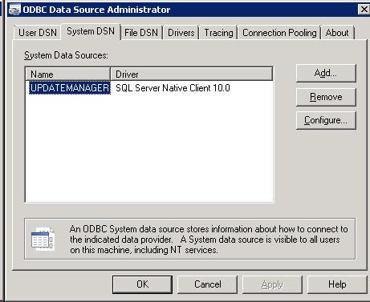

Follow the normal steps and plug in the required data to create your new 32 bit ODBC connection and you are done.